DIAGNOSTIC TEST

“UNEXPECTED EVENTS”

1. Write the name of the disaster using the word bank

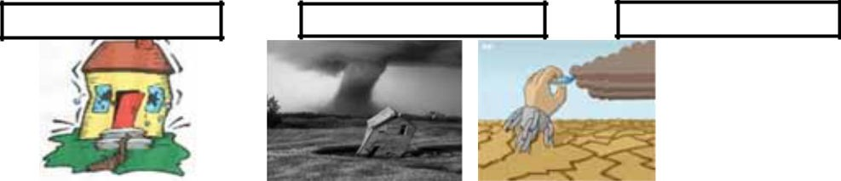
Ă
Đ

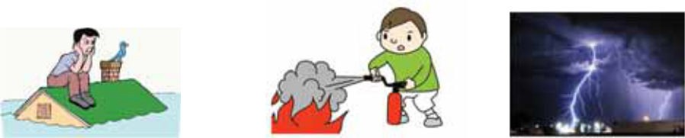
Ě

Word bank: Wildfire – Tornado – Earthquake – Storm – Drought – Flood

2. Read and complete with some connectors using the word bank

Word bank:
instead of, not only, as well as, either, but also, nor, neither, therefore, moreover, however, on the contrary

The strongest earthquake in the 2011
Colombia suffered the strongest earthquake during the last year. The natural event destroyed buildings and houses, many cars and some of the main streets were affected by the disaster. there weren't human victims have been reported disappeared people.
However some animals were victims of this unexpected event.

- Imagine you are a journalist. Then write a report according to the picture. Describe by using different tenses:

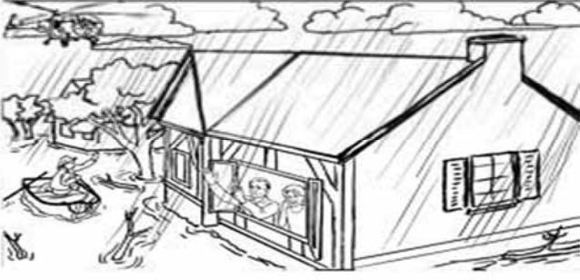

WORKSHOP 1
WEEK: FROM TO 202 HOURS: EXPRESSIVEPURPOSE
That I develop reading comprehension showing my advances by organizing stories and contrasting verbs with pictures.

EVALUACIÓN: INDICADOR O INDICADORES DE DESEMPEÑO:
Identifico ideas generales y específicas en textos orales, si tengo conocimiento del tema y del vocabulario utilizado.

Tell us about you:

- What did you like when you were younger?
- What do you like now?

Now ask your partner:

  - What did she or he like when he or she were younger?

•What does he or she like now?

REVIEW

 | Simple present tense |  |  | Example | Simple past tense |  |  | Example
 | affirmative | negative I | nterrogative |  | Affirmative | negative I | nterrogative
I/  you/  they/ we | Verb  doesn’t change | Do not | Do | * you go to the library  *You do not go to the library  *Do you go to the  library? | Verb in  the past form | Didn’t | Did | *you went  to the  library  *You did not go to the library  *Did you go to the  library?
He/  she/ it | Verb  adds:  “s” “es” “ies” | does  not | Does | *He goes to  the library  *He does not go to the library  *Does he go to the  library? | Verb in  the past form | Didn’t | Did | *He went to  the library  *He did not go to the library  *Did he go to the  library?

The simple present tense, a verbal tense that expresses daily routines or habits, is different from the past tense that expresses actions done in the past. This explanation is according to the grammar rules.

To organize a story you should take into account the following tips:

- Recognize the vocabulary you know to get a general idea, after that look in your dictionary for the vocabulary you do not know to have better comprehension.
- Identify the paragraph’s content.
- Establish the structure of the text: introduction, body and conclusion.
- The order of the text may vary according to the author’s style, but all the texts have coherence and cohesion.
- Try with different paragraphs in order to be sure that the paragraph you chose is the correct one.
ACTIVITY
Name the parts of the text: Introduction, body, conclusion. Japan Tsunami Taller Than 10-Story Building
Giant wave was biggest recorded in decades: Experts by Rob Quinn, Newser Staff Posted Jul 19, 2011 1:40 AM CDT | Updated Jul 19, 2011 7:00 AM CDT
: The tsunami was at its tallest when it struck the port city of Miykao, according to experts who measured marks left on buildings and trees in the valley where the town sits. The largest tsunami ever recorded was in Alaska in 1958, when a landslide caused a mega-tsunami 1,720 feet tall—470 feet higher than the Empire State Building—to sweep through the Lituya Bay inlet.
: The tsunami that struck Japan in March rose to a staggering 132.5 feet at its highest, taller than a 10 -story building, according to 150 researchers who have collected data from thousands of locations along the country's east coast.

: Here's how it stacks up: The killer wave was taller than the 2004 Indian Ocean tsunami (108 feet), taller than Rio's Christ the Redeemer statue (130 feet), and taller than any other tsunami recorded in Japan (125.3 feet, in 1896), the Telegraph reports.

Underline the past actions in the text and classify. Answer the following questions:
What happened? When? Where? Who were the people involved? What were the consequences?

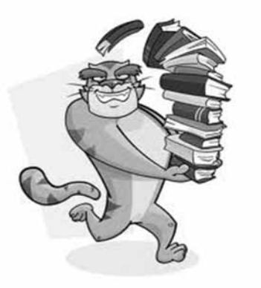

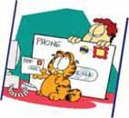

  - Read, organize the story and underline some simple present and simple past sentences, write the sentences on your notebook.

Dusk to Dawn: Survivor Accounts of the Last Night on the Titanic
Eight o'clock on April 14 found many of the passengers at dinner. The weather continued to be clear and calm, and all agreed the Sunday evening dinner was the best yet. Since the ship was on its fifth day out, casual acquaintances were evolving into friends. The passengers were comfortable with the ship's daily schedule. I doubt that
anyone at dinner was discussing the possibility of striking an iceberg and sinking.

On Wednesday, April 10, 1912, the Titanic set sail for America from Southampton. She planned to reach New York the following Wednesday. By April 16 the entire world was shocked to find that this majestic ocean liner had sunk. In April of each year, another anniversary of the historic event makes the news. I had the opportunity to read a book by Paul J. Quinn on the subject. Mr. Quinn's first book, Titanic at Two A.M., primarily
focused on the last 20 minutes before the ship sank. This book starts earlier in the evening and continues hour by hour through that awful historic night.

The bow of the Titanic slipped into the dark sea at two o'clock, barely making a ripple. The story continues through the night, the survivors testifying as to the horrors they saw and heard in the darkness. Dawn came early over the sea, and the sky began to lighten at four a.m. Soon afterward, the Carpathia arrived and began picking up the relatively few remaining passengers. Some of those who survived testified before the Senate, and Mr. Quinn quotes them throughout the book. Others never spoke of their ordeal, not even to their families. All of those who did survive carried the distinction of "Titanic
survivor" the rest of their lives.

For the next few hours, the passengers were engaged in the entertainment on board-- cards, music, dancing, and relaxing in the bars. Some wandered off to bed. Throughout the early evening hours the crew was into its normal routine. They too were just getting acquainted with each other, since this was the Titanic's maiden voyage. Mr. Quinn uses the survivors' stories to vibrantly discuss this last haunted evening on the fated ship. He weaves the passengers and crews remembrances well, making you feel like you are on
the ship.

Taken from: http://cruises.about.com/od/cruisereading/gr/titanic_dusk_to_dawn.htm

